AIT 524: Weekly Assignment 04
Tanmoy Chowdhury
George Mason University

Author Note
This task is being submitted as an assignment task 04 for the course ‘Database Management Essential’ offered in Sprig 2018. For any kind of inquiry, feel free to contact at tchowdh6@masonlive.gmu.edu.

Online Drill
Based on the feedback on my Assignment 03 I made change in EER diagram and Business rule. Moreover, business rule also covers the new task from assignment 04. So, there are changes in entities also.

Necessity of database for this online-drill company
This website contains subscriber with different skill set. A player can register for different type as like Goal-keeper, defense, Stricker. Every type has three skill levels as like beginner, intermediate and expert. Moreover, it has lot of motion pictures which are categorized in different panels. It would become messy if it is not organized in a database. That is why, this online company needs a database.

Business Requirements:
The goal of this website is to provide training for the players. A player can hesitate at the very beginning level about his playing position. As like, a player can be interested in either goal-keeper or defense or striker. Again, a player can be interested in all three types. Every type consists of three different level as like beginner, intermediate, and expert level. For better understanding the scenario, think about a player ‘John’ of age 14. This player can be enrolled as Goal-keeper Beginner Level, Defense Expert Level and Striker Intermediate level simultaneously.
For every category of playing, there would be drill set for dribbling, passing and shooting. For instance, John has already enrolled for Goal-Keeper Beginner Level. This category can be consisting of 2 dribbling drills, 1 passing drills and 5 shooting drills.
In a summery, a player can enroll among 9 categories (Goal-Keeper, Defense, Stricker with Beginner, Intermediate, Expert level) as much as he wants. Every category consists of drill from 3 sets (Dribbling, Passing, Shooting). A drill can be only one type either dribbling or passing or shooting. One drill cannot be part of two different sets.
Based on the business scenario, this website would contain many entities. I hope to come up with a perfect set of entities though out this course by brainstorming more and more. As an initiative step, I have figured out four entities. They are Player, Category, Drill and PlayerCatDrill. At first I am pointing the business rules and then the description of entities and relationship will be stated.
Business Rules (Modified):
- A player can be Goalkeeper, Defense, Stricker. (Newly Added)
- A player type must be in one type among Beginner, Intermediate, Expert
- Each player can enroll in one or more categories. One category can have more than one players. (M:N relationship)
- One category can consists of many drill and one drill can be part of many categories. (M:N relationship)
- A drill must be in one type among passing, dribbling, shooting.
The explanation I have described already at the beginning of this paragraph ‘Business Requirements’.
Entities of the system
In previous paragraphs I have discussed the business scenario and the cause of choosing the entities. If we want to have a detail version of the entities, then we can end-up as like following:
PLAYER:
This entity is the very beginning step of this web for user-interaction. A user will open his account. Every player will possess an unique id. He can choose one or more category id among those 9 categories. He will not be allowed to choose other than those.
- player_id: A unique id choose by user. It would be VARCHAR. Maximum 10 character will be allowed.
- email: Mandatory attribute as it is necessary to contact with player. Type: VHARCHAR.
- age: Number type

CATEGORY:
Every category would have id (1~9). For more detail description it would contain the attribute player_type and player_level. Moreover, it would also contain player_id and drill_id.
- category_id: (1~9) (Category Chart has been attached here)
- player_type: (Goalkeeper/Defense/Stricker)
- player_level: (Beginner/Intermediate/Expert)

1 | Goalkeeper-Beginner ‘01GLBG’
2 | Goalkeeper-Intermediate ‘02GLINT’
3 | Goalkeeper-Expert ‘03GLEX’
4 | Defense-Beginner ‘04DFBG’
5 | Defense -Intermediate ‘05DFINT’
6 | Defense -Expert ‘06DFEX’
7 | Striker-Beginner ‘07STBG’
8 | Striker -Intermediate ‘08STINT’
9 | Striker -Expert ‘09STEX’
Table 01: Category table
DRILL:
For drill, it should have unique id and type. It will also have duration of every drill in seconds.
- drill_id: VARCHAR (10)
- drill_type: (Dribbling/Passing/Shooting)
- drill_duration: number

PLAYERCAT:
It is very difficult to implement many-to-many relationship in case of relational database. So, for making the relations among those three entities this PLAYCATDRILL entity is necessary. It has three attributes whose is not only as primary key but also as foreign key.
- player_id: VARCHAR
- category_id: (1~9)
CAT_DRILL:
It is very difficult to implement many-to-many relationship in case of relational database. So, for making the relations among those three entities this CAT_DRILL entity is necessary. It has three attributes whose is not only as primary key but also as foreign key.
- category_id: (1~9)
- drill_id: (1~9)

Relationship
I would like to depict the relationship in a table with evaluation.
Entity 1 | Entity 2 | Relationship | Cause
PLAYER | CATEGORY | Many-to-Many | A player can be enrolled in many categories again one category can contain many players
PLAYER | DRILL | Many-to-Many, Weak | A player can practice many drills and one drill can contain many players.  It is weak relationship because, these two entities do not contain any parent key components among them. They are not existence-dependent on each other.
DRILL | CATEGORY | Many-to-Many, Weak | Every category is built with drill set of many drills. Similarly, every drill can be part of many categories.  It is weak relationship because, these two entities do not contain any parent key components among them. They are not existence-dependent on each other.
PLAYER/CATEGORY  (This has been modified) | PLAYERCAT  (This has been modified from previous assignment) | One-to-Many, Strong | One instance from any of these two entities (PLAYER/CATEGORY) is related to many instances of PLAYCAT entity.  It is strong relationship because, PLAYER, CATEGORY contains primary key component from PLAYERCAT. PLAYERCAT has composite primary key. This entity is dependent on PLAYER and CATEGORY. So, it is a strong relationship.
CATEGORY/DRILL | CAT_DRILL  (This is newly added) | One-to-Many, Strong | One instance from any of these two entities (DRILL/CATEGORY) is related to many instances of PLAYCAT entity.  It is strong relationship because CATEGORY OR DRILL contains primary key component from CAT_DRILL  . CAT_DRILL  has composite primary key. This entity is dependent on DRILL and CATEGORY. So, it is a strong relationship.
Table 02: Entity Relationship
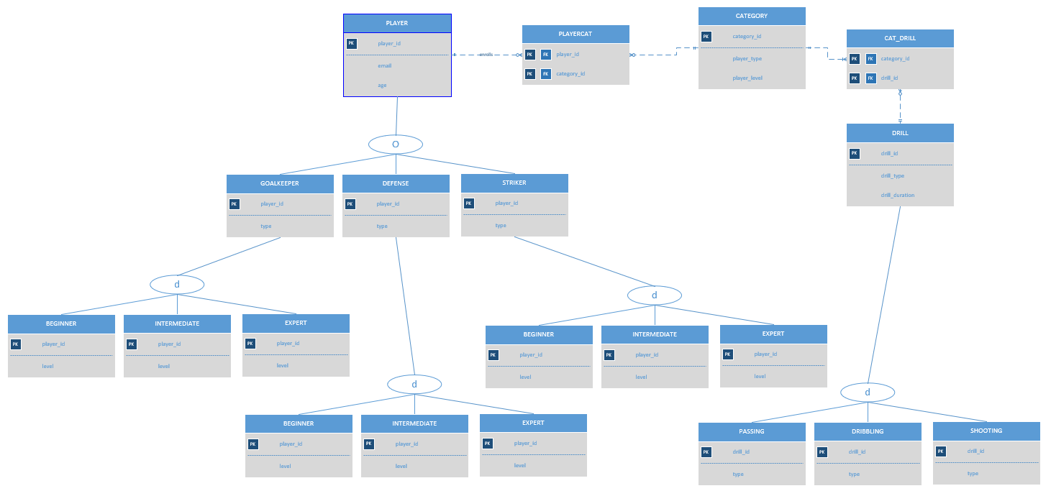
Figure 01: Entity Relationship Diagram

References
Elmasri, R., Navathe, S. B. (2016). Database system concepts and architecture in M. J. Horton, Fundamentals of Database Systems (7th ed., pp 31-56) : Pearson.

